
SOUTH EAST EDUCATION DIVISION EXAMINATIONS

2026 MALAWI SCHOOL CERTIFICATE OF EDUCATION MOCK EXAMINATION

GEOGRAPHY
Subject Number: M073/II
Tuesday, 24 March Time Allowed: 2 hours
1:30 - 3:30 pm
PAPER II
(100 marks)
HUMAN AND ECONOMIC GEOGRAPHY
Instructions:

- This paper contains 10 printed pages. Please check.
Question Number | Tick if answered | Do not write in these columns
1

2

3

4

5

- Write your Examination number at the top of each page.
- This paper has two sections, A and B.
- The number of marks for each answer are indicated against the question.
- In the table provided on this page, tick against the number of the question you have answered.
- Hand in your question paper to the invigilator when time is called to stop writing.

©2026 SEED MOCK Turn over

Section A (75 marks)
Answer all the questions in this section in the spaces provided.
- a (i). Give any two aims of World Trade Organisation.
_________________________________________________________________________
________________________________________________________________ (2 marks)
(ii) State any two ways how World Trade Organisation promotes world trade.
_______________________________________________________________________________________________________________________________________________________________________________________________________________________________________________________________________________________ (2 marks)
(iii) Give any two main roles of customs.
_______________________________________________________________________________________________________________________________________ (2 marks)
b. (i) State any two characteristics of extensive farming.
_______________________________________________________________________________________________________________________________________ (2 marks)
(ii) State any two disadvantages of intensive farming.
_______________________________________________________________________________________________________________________________________________________________________________________________________________________________________________________________________________________ (2 marks)
b. Explain any two economic importance of railway transport.
_______________________________________________________________________________________________________________________________________________________________________________________________________________________________________________________________________________________ (4 marks)

Continued/…
c. Figure 1 is a world map showing world shipping routes. Use it to answer
questions that follow. 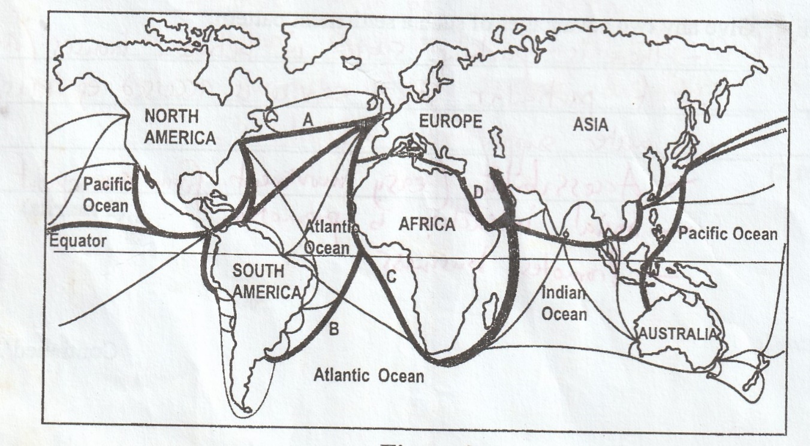
Figure 1
- Identify shipping routes A, B and C
A: ___________________________________________________ (1 mark)
B: ____________________________________________________ (1 mark)
C: ___________________________________________________ (1 mark)
- State one advantage of using shipping route D over shipping route C to European states?
_______________________________________________________________________________________________________________________________________ (2 marks)
- Give any two main goods transported through shipping route D
___________________________________________________________________________________________________________________________________________________ (2 marks)
b. Explain any one way in which each of the following promote tea growing in Malawi
- Soil
___________________________________________________________________________________________________________________________________________________ (2 marks)
- Humidity
___________________________________________________________________________________________________________________________________________________ (2 marks)
Continued/…
2 a. (i) Describe any two physical conditions which promote irrigation farming
_______________________________________________________________________________________________________________________________________________________________________________________________________________________________________________________________________________________ (4 marks)
(ii) State any one solution to the problem of soil salinity caused by irrigation farming.
_______________________________________________________________________________________________________________________________________ (1 mark)
b. (i) Explain how water for irrigation is distributed in Israel
_______________________________________________________________________________________________________________________________________ (2 marks)
(ii) Describe any two methods of irrigation used in Israel
_______________________________________________________________________________________________________________________________________________________________________________________________________________________________________________________________________________________ (4 marks)
(iii)Explain how water for irrigation is treated using vacuum freezing method in Israel.
_______________________________________________________________________________________________________________________________________________________________________________________________________________ (3 marks)
c. State any three farm activities that occur in rice farms.
___________________________________________________________________________________________________________________________________________________________________________________________________________________________ (3 marks)
d. Explain why rice farming requires each of the following conditions.
(i) Flat topography
_______________________________________________________________________________________________________________________________________ (2 marks)

Continued/…
(ii)Soils with impervious subsoil
_______________________________________________________________________________________________________________________________________ (2 marks)
e. Describe any two problems that affect dairy farming in Denmark
_______________________________________________________________________________________________________________________________________________________________________________________________________________________________________________________________________________________ (4 marks)

3 a. Describe each of the following ways of managing wastes.
- Resource recovery
_______________________________________________________________________________________________________________________________________ (2 marks)
- Recycling
_______________________________________________________________________________________________________________________________________ (2 marks)
b.(i) State any two signs of poor waste disposal in cities of Malawi
_______________________________________________________________________________________________________________________________________ (2 marks)
(ii)Explain any two effects of poor waste disposal in Malawi
___________________________________________________________________________________________________________________________________________________________________________________________________________________________________________________________________________________________ (4 marks)
c. Describe any three benefits of climate change interventions.
_______________________________________________________________________________________________________________________________________________________________________________________________________________________________________________________________________________________________ (4 marks)
d. (i) Explain any one environmental benefit of using solar energy over thermal energy
___________________________________________________________________________________________________________________________________________ (2 marks)
Continued/…
(ii) With aid of a diagram, explain how geothermal energy is produced.

_______________________________________________________________________________________________________________________________________________________________________________________________________________________________________________________________________________________ (7 marks)
e. Classify the following minerals into organic, metallic and non-metallic minerals.
Tin, Petroleum, Phosphate
Organic | Metallic | Non-metallic
- marks)
Section B (25 marks)
Answer one question only from this section in the spaces provided
4. a. Figure 2 has two diagrams showing settlement patterns. Use them to answer
questions that follow
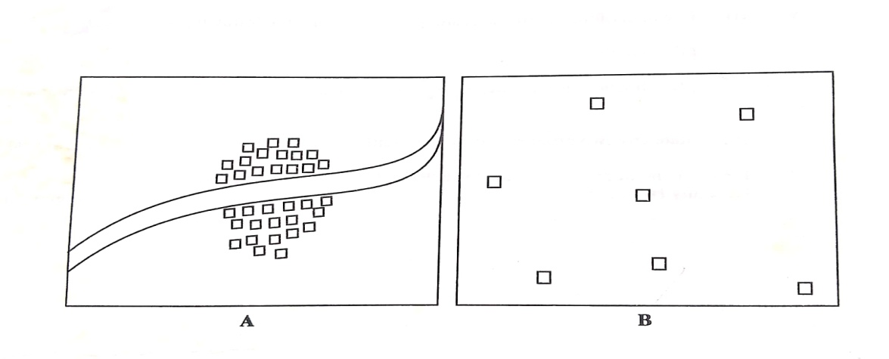

Figure 2

- Identify the settlement pattern A.
A: ______________________________________________________________ (1 mark)
- Explain any two social factors that lead to the development of settlement pattern A.
_______________________________________________________________________________________________________________________________________________________________________________________________________________________________________________________________________________________ (4 marks)
- State two differences between settlement pattern A and settlement pattern B
________________________________________________________________________________________________________________________________________ (2 marks)
b. Explain any one way in which each of the following challenges of urbanization
can be solved.
- Environmental deterioration
_______________________________________________________________________________________________________________________________________ (2 marks)
- Congestion
_______________________________________________________________________________________________________________________________________ (2 marks)
c. Describe any two economic characteristics of the Central Business District
_______________________________________________________________________________________________________________________________________________________________________________________________________________________________________________________________________________________ (4 marks)
d.(i) Describe any two factors that have led to the growth of lake Malawi as a
tourist attraction feature
_______________________________________________________________________________________________________________________________________________________________________________________________________________________________________________________________________________________________ (4 marks)

Continued/…
(ii)Explain how raw materials influence location of industries
_______________________________________________________________________________________________________________________________________ (2 marks)
Figure 2 is map of the world showing world population densities. Use it to
answer questions that follow.
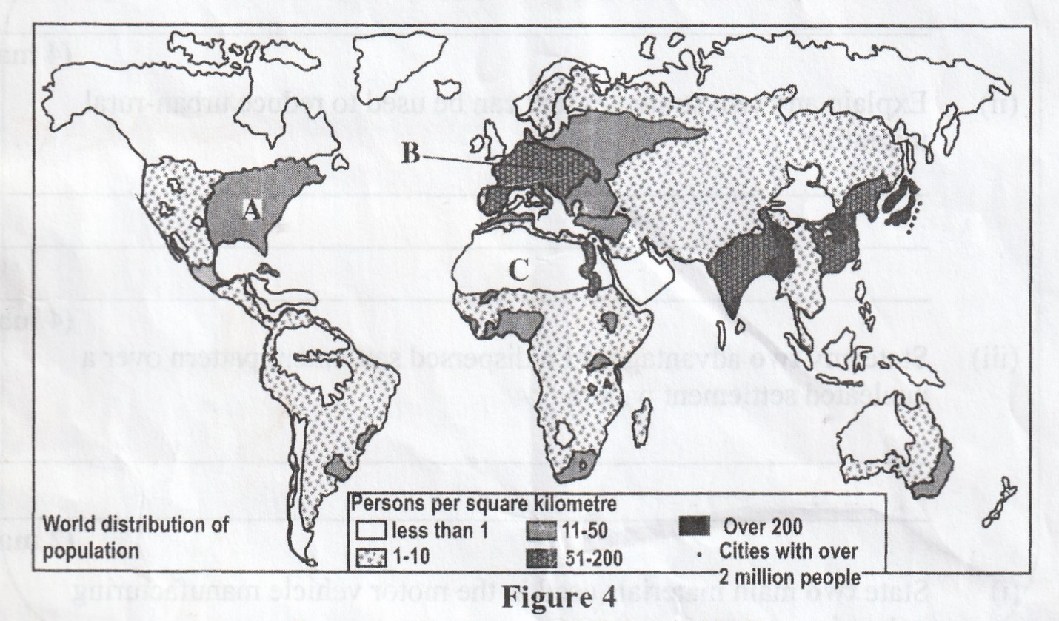

- Give any one reason for high population in region A
_______________________________________________________________ (1 mark)
- Why does region C have low population?
_______________________________________________________________________________________________________________________________________ (2 marks)
- Name any one country that is found in region C
________________________________________________________________ (1 mark)

Continued/…
5. a. Explain one difference between rural and urban settlement under each of the
following factors
- Economic activities
_______________________________________________________________________________________________________________________________________ (2 marks)
- Size of population
_______________________________________________________________________________________________________________________________________ (2 marks)
b. With aid of a diagram, describe a linear settlement pattern

_______________________________________________________________________________________________________________________________________ (2 marks)
c. Explain how urbanization promote each of the following
(i) Economic development
_______________________________________________________________________________________________________________________________________ (2 marks)
(ii) Increase in crime
_______________________________________________________________________________________________________________________________________ (2 marks)
d. Describe any two problems associated with the high-class housing zone of a city
_______________________________________________________________________________________________________________________________________________________________________________________________________________________________________________________________________________________ (4 marks)
e. (i) Explain any two ways how eco-tourism still promotes environmental damage
________________________________________________________________________________________________________________________________________________________________________________________________________________________________________________________________________________________ (4 marks)
Continued/…
- Describe one physical factor that has led to the growth of Japan as a major
Industrial area
_______________________________________________________________________________________________________________________________________ (2 marks)
c. Figure 3 shows population graphs for countries X and Y. Use it to answer
questions.

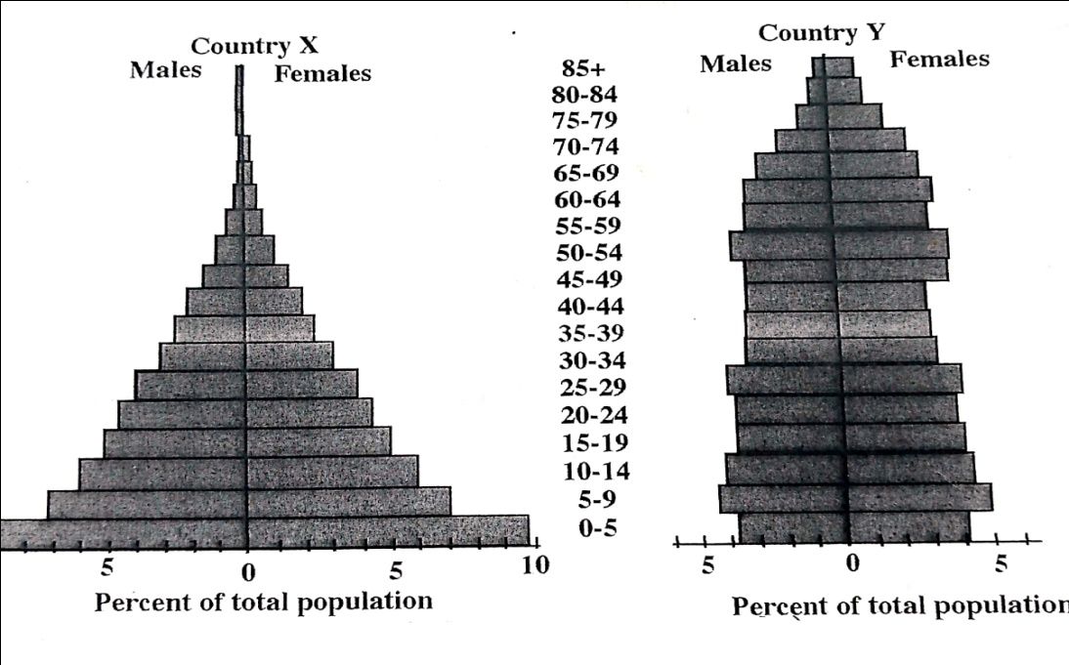
Figure 3
- Which country has similar population pyramid as that of Malawi?
_______________________________________________________________ (1 mark)
- Which country has higher life expectancy?
_______________________________________________________________ (1 mark)
- Explain any one reasons why country X has that shape of graph.
_______________________________________________________________________________________________________________________________________ (2 marks)

END OF QUESTION PAPER
NB: This paper contains 10 printed pages.

